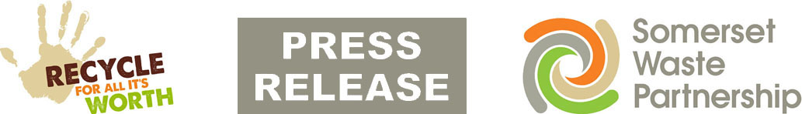

For Immediate Release 24, March, 2020

Recycling centres closed and bulky collections suspended

All of Somerset’s Recycling Centres have been closed until further notice as a result of the Coronavirus.

This follows the latest Government advice on avoiding non-essential contact and travel, and the challenges of ensuring public and staff safety at the busy sites where physical distancing is difficult.

The closure applies to all 16 Recycling Centres across the county, all of which are operated by Viridor for the Somerset Waste Partnership.

All recycling, refuse and clinical collections are due to take place today (24.3.20), despite dozens of staff not being able to come to work as a result of coronavirus.

However, the Partnership is suspending its bulky waste collections from tomorrow, so that staffing can be diverted to these other collections. Customers with existing bookings will be contacted in the coming days.

The Partnership is asking for the public’s patience and understanding and requesting that people:

- Hold on to garden waste until the centres reopen. Home composting of grass cutting and hedge trimming may be an option for some and advice on this can be found here (https://www.somersetwaste.gov.uk/home-composting/)
- Hold on to any bulky waste items and other materials until the centres reopen.
- Do not leave waste outside the centres – Leaving waste outside centres or elsewhere is fly tipping, a criminal offence for which people can be prosecuted.

We are working hard with partners and contractors to keep services going, with collection crews classed as key workers providing an essential service.

However, disruption has been unavoidable as staffing numbers fall and several SWP services have been suspended.

- Suspended - all garden waste collections until further notice. Subscribers are advised to leave the waste in their green bin until collections resume, or consider home-composting if that’s practical.
- Suspended - new requests for bins, recycling boxes and food waste caddies. Teams will try to deliver those already ordered, but no new requests will be accepted for the time being.
- Suspended – bulky waste collections.
- Paused – Slim My Waste, Feed My Face campaign. A decision on delivering the campaign to the remaining areas of Sedgemoor and West Somerset will be taken at a later date.

Please check www.somersetwaste.gov.uk/coronavirus for latest information about service disruptions and guidance about disposing of any personal waste – like tissues or disposable cleaning cloths - that might be contaminated.
Please follow @somersetwaste on Twitter and Facebook for the latest updates.

[END]
Notes to editors

Somerset Waste Partnership manages waste services for all councils in Somerset.

SWP media contact:
Nick Cater, Senior Communications Officer Nick Cater,
Nicholas.Cater@somersetwaste.gov.uk
Mark Ford, Head of Communications and Engagement, 07977412198 mford@somersetwaste.gov.uk

